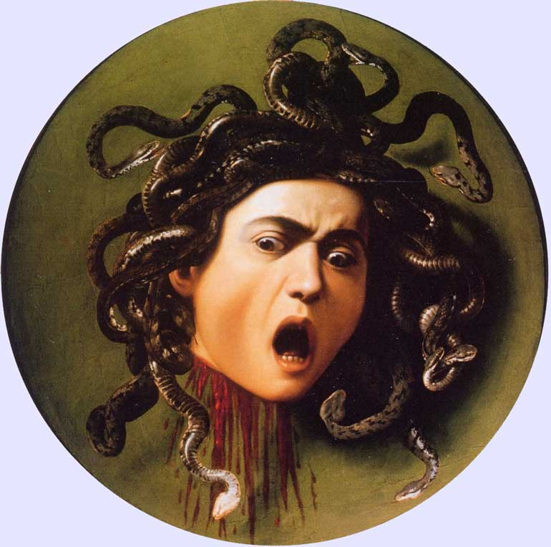
(Art 257)
Caravaggio, Medusa, c. 1596-97

Medusa’s Gaze: Art in the Age of Galileo

Classroom: 222 McWethy M-F 10-11 am and 1-3 pm (there are a few exceptions)
Professor: Christina (McOmber) Penn-Goetsch Home: 319 338-7438 email: cpenngoetsch@cornellcollege.edu
Office: McWethy 214 (319) 895-4137
Office Hours: Thursday, 3-5pm and by appt.

The tale of Medusa functions as a metaphor for the creation and power of art in the Baroque age. The term “Baroque” refers to the diverse styles of one of the most vivid, passionate, and theatrical periods of art in Europe that followed the religious upheavals of sixteenth century. It is no wonder that the art of the Counter Reformation appropriately begins in Rome, but this context also is where we find the beginnings of installation art and a new emphasis on the body as a primary means of expression. The unbounded passion and gore may allow us to consider the visceral image of Caravaggio’s gorgon as a symbol for the art of this period. But due to the vivid naturalism and the dependence on interaction with an audience in much of the art, the work continues to inspire many contemporary artists on theoretical and material levels.

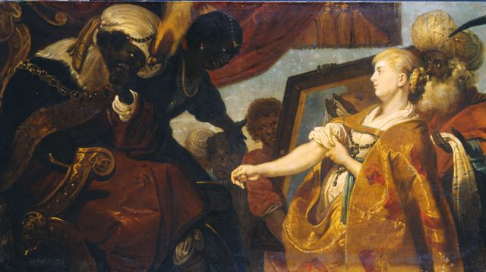
In fact, we will consider the diverse styles of the period within the social context of their creation. Rome only offers a springboard into considering a vast flowering of new approaches to painting, sculpture, and architecture in Catholic and Protestant arenas as well as its rhetorical function for the papacy and monarchies of Europe. Art not only helped establish the status of the artist, but it often served as a rhetorical tool, a vehicle of ideologies that supported political endeavors and societal attitudes. This intermediate level course will examine the visual culture of Italy, Flanders, Spain, Mexico, France, and the Netherlands in the seventeenth century. There are strong political, violent, sexual, and religious aspects to much of this art; therefore, be forewarned. Let me know if a particular topic is disturbing to you based on personal history. I can let you know in order for you to be better prepared and decide whether you need to miss a section or portion of class discussion.
Karel van Mander III, Persina and Hydaspes Recognize their Daughter, 1645

Course Objectives that consider the Educational Priorities of Cornell College:
- Recognize a number of well-known art and architecture from seventeenth-century Europe and their historical significance (intercultural literacy and knowledge).
- Understand the relationships between art production and gender, politics, colonialism, religion, and economics in early modern Europe (Intercultural Literacy and Ethical Behavior).
- Articulate some of the methodologies employed by art historians addressing this subject (Reasoning and Communication).
- Engage in thoughtful discussions about aesthetics, vocations in art/architectural history, and the appropriate use of primary sources (Vocation and Communication).
- Develop stronger reading, writing, and research skills (Inquiry).

Course Evaluation (Art 257)
Class Participation* (regular attendance alone--attending at least 17 class days--is equivalent to a “C”) 10%
Gender Theory Essay 15%
Midterm 25%
Research Project 25%
Final Exam (Covers the second half of the course.) 25%

*Inevitably, there are days when one must miss a class session. Nevertheless, some sort of explanation as to why you were unable to attend class is expected via email or in person. This represents polite and thoughtful behavior in any context, but it is even more important when an entire group is expected to be contributing to the class.

Required Books at Cornell’s Bookstore
(Books are also available at Cole Library Reserves)

Howard Hibbard, Bernini, reprint edition, Harmondsworth, Middlesex, England: Penguin Books, 1990.

Eve Straussman-Pflanzer, Violence & Virtue: Artemisia Gentileschi’s Judith Slaying Holofernes, Chicago: Art Institute of Chicago, 2013.

Troy Thomas, Caravaggio and the Creation of Modernity, London: Reaktion Books, 2016.

Critical Logistical Information

I am usually available for office (214 McWethy) hours after class on Thursdays (3:00 to 4:00 p.m.) or by appointment. When looking for me, do not limit your search to the office. I often work in the slide room (206) or upstairs in the studio classrooms. Slides or images will be posted as flashcards on the Moodle site at the end of each week. These are the works that might come up on exams. Unless listed otherwise, classes meet at 10:00 a.m. and 1:00 p.m.

Students who need accommodations for learning disabilities must provide documentation from a professional qualified to diagnose learning disabilities. For more information see
cornellcollege.edu/disabilities/documentation/index.shtml

Students requesting services may schedule a meeting with the disabilities services coordinator as early as possible to discuss their needs and develop an individualized accommodation plan. Ideally, this meeting would take place well before the start of classes.

At the beginning of each course, the student must notify the instructor within the first three days of the term of any accommodations needed for the duration of the course. If you have documented needs that require a change in testing procedures or assignments, please do let me know as soon as possible. I will do whatever I can to make the necessary adjustments.

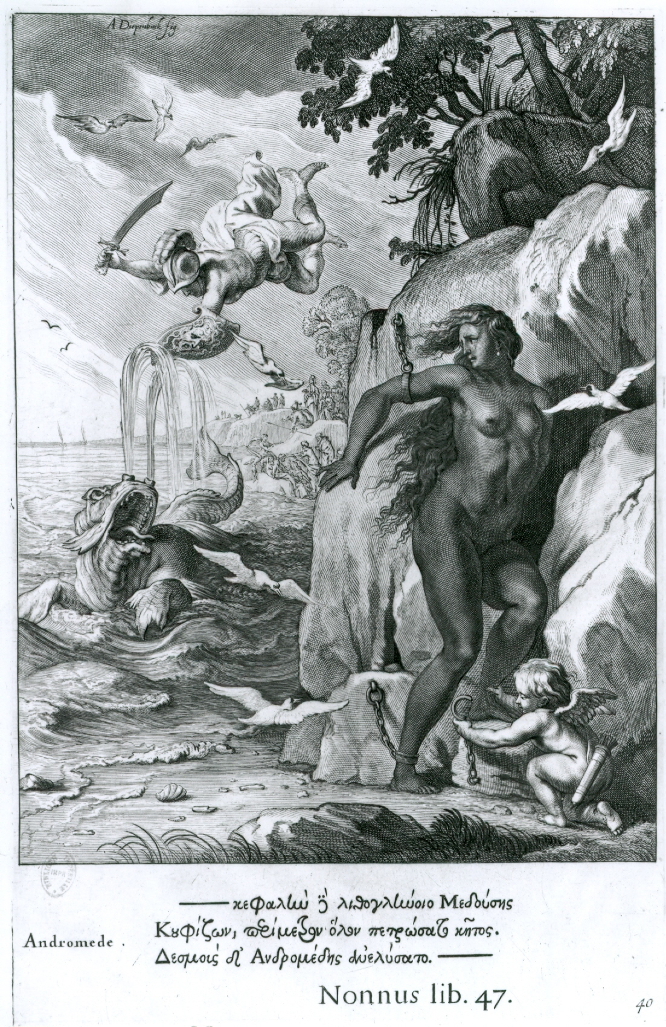
Bernard Picant (1731) after Abraham van Diepenbeeck, Perseus and Andromeda, 1655.

List of Some Useful Sources in the Cole Library

Alpers, Svetlana The Art of Describing: Chicago: 759.9492 AL74a University of Chicago Press, 1983.

Avery, Charles Bernini: Genius of the Baroque, 730.924 B45a 1997
London: Thames and Hudson, 2006.

Bacchi, Andrea and Bernini, Milan: Officina Libraria, 2017. 730.92 B456bc 2017
Anna Coliva, eds. (Reserve)

Baldanucci, Filippo The Life of Bernini, trans. by Catherine Enggass, 730.924 B456b
University Park, PA: Pennsylvania State University
Press, 1966.

Bal, Mieke Quoting Caravaggio: Contemporary Art, 700.4112 C176b 1999
Preposterous History, Chicago:
University of Chicago Press, 1999.

Belkin, Kristin Lohse Rubens, London: Phaidon, 1998. 759.9493 R82r
(Reserve)

Benesch, Otto Rembrandt, New York: Rizzoli, 1990. 759.9492R28b

Bersani, Leo and Caravaggio’s Secrets, Cambridge: 759.5 C17b 1998
Ulysse Dutoit MIT Press, 1998.

Bissell, Ward Artemisia Gentileschi and the Authority of Art, 759.5 G289b 1999
University Park, Pennsylvania: Penn State Press, Oversize
1999. (Reserve)

Brown, Jonathan Velázquez, New Haven, Connecticut: 759.6 V5416
Yale Press, 1986. (Reserve) Oversize

Carrera, Magali Marie Imagining Identity in New Spain: Race, Lineage, 757 C233i
and the Colonial Body in Portraiture and 2003
Casta Paintings, Austin, TX: University of
Texas Press, 2003.
Carroll, Margaret “The Erotics of Absolutism: Rubens and the 704.042 Ex71
Mystification of Sexual Violence,” in The
Expanding Discourse: Feminism and Art History ,
Mary Garrard and Norma Broude, eds., New York:
Icon Editions, 1992, 139-59.

Chong, Alan and Still-Life Paintings from the Netherlands 758.4 C455st
Wouter Kloek 1550-1720 , Zwolle: Waander Publishers, Oversize
1999. (Reserve)

Christiansen, Keith Orazio and Artemisia Gentileschi, New York: 759.5 G289e 2001
and Judith Mann, eds. Metropolitan Museum of Art, 2001. Oversize

Garrard, Mary “Artemisia and Susanna,” in Feminism and Art 701.03 F349
History: Questioning the Litany, M. Garrard and
N. Broude, eds., New York: Harper & Row, 1982,
147-71. (Reserve)

__________. Artemisia Gentileschi: The Image of the Female 759.5 G289g
Hero in Italian Baroque Art, Princeton, New Jersey:
Princeton University Press, 1989. (Reserve)

__________. Artemisia Gentileschi Around 1622, Berkeley: 759.5 G2893g
University of California Press, 2001.

Harris, Ann Sutherland Seventeenth-century Art and Architecture, 709.032 H24s 2005
Upper Saddle, New Jersey: Pearson Prentice Oversize
Hall, 2005. (Reserve)

Held, Julius and 17th and 18th Century Art, 709.032 H36s
Donald Posner New York: Abrams Press, 1971. Oversize

Hibbard, Howard Bernini, reprint edition, Harmondsworth, 730.924 B456h 1965
Middlesex, England: Penguin Books, 1990.
(Reserve)

Hibbard, Howard Caravaggio, New York: Harper & Row, 1983. 759.5 C17h
(Reserve)

Hochstrasser, Julie Still Life and Trade in the Dutch Golden Age, 758.4 H658s 2007
Berger New Haven: Yale University Press, 2007. (Reserve)

Hofrichter, Frima Fox “Judith Leyster’s Proposition: Between Virtue 701.03 F349
and Vice,” in Feminism and Art History:
Questioning the Litany, M. Garrard and N.
Broude, eds., New York, Harper &
Row, 1982, 173-81. (Reserve)

__________. Judith Leyster: A Woman Painter in Holland’s 759.9492 L594h
Golden Age, Doornspijk, Netherlands: Oversize
Davaro, 1989.

Jones, Pamela Altarpieces and their Viewers in the Churches 704.948z J723a 2008
in the Churches of Rome from Caravaggio
to Guido Reni, Burlington, VT: Ashgate, 2008.

Kahr, Madlyn Dutch Painting in the Seventeenth Century, 759.9492 K122d 1993
Cambridge: Perseus, 1993.

Katzew, Ilona Casta Painting: Images of Race in Eighteenth- 757 K159c
century Mexico, New Haven: Yale University 2004
Press, 2004.

Kitao, Timothy Circle and Oval in the Square of Saint Peter’s: 720.924 B4756 1974
Bernini’s Art of Planning, New York: New York Oversize
University Press, 1974.

Kris, Ernst and Otto Kurz Legend, Myth, and Magic in the Image of the 701.15 K987L
Artist: A Historical Experiment, New Haven:
Yale University Press, 1979.

Langdon, Helen Caravaggio: A Life, Colorado: Westview Press, 759.5 C17L
2000.

Lavin, Irving Bernini and the Crossing of Saint Peter’s, 730.924 B456 1968
New York: New York University Press, 1968.
(Reserve)

Locker, Jesse Artemisia Gentileschi: The Language of 759.5 G289Lo 2015
Painting. New Haven: Yale University Press,
2015. (Reserve)

Marder, Tod A. Bernini and the Art of Architecture, New York: 720.924 B457m
Abbeville Press, 1998. (Reserve) Oversize

Martin, John Rupert, Farnese Gallery, Princeton: Princeton 759.5 M364f 1965
University Press, 1965. (Reserve) Over Size

__________. Rubens: The Antwerp Altarpieces , New York: 759.9492 R82ma
Norton & Co., 1969.

__________. Baroque, New York: Harper & Row, 1977 709.032 M364b
(Reserve)

Montagu, Jennifer Roman Baroque Sculpture: The Industry of Art, 730.945 M76r
Second ed., New Haven: Yale University Press,
1992. (Reserve)

Neuman, Robert Baroque and Rococo Art and Architecture
Upper Saddle, NJ: Pearson, 2013 (Reserve)

Pollock, Griselda “Feminist Dilemmas with Art/Life Problem,” 759.5 G289ba
in The Artemisia Files: Artemisia Gentileschi 2005
for Feminists and Other Thinking People,
Mieke Bal, ed., Chicago: University of
Chicago Press, 2005, 169-206; 211-12.
(Reserve)

Puglisi, Catherine Caravaggio, London: Phaidon, 1998. 759.5 C17p 2004
(Reserve)

Robb, Peter The Man Who Became Caravaggio, 759.5 C17r 2000
New York: Picador, 1998.

Rosenthal, Lisa Gender, Politics, and Allegory in the Art of 759.9493 R824 2005
Rubens, Cambridge: Cambridge Press, 2005.

Schama, Simon Rembrandt’s Eyes, New York: Alfred A. Knopf, 759.9492 R28sc
1999. (Reserve)

Scott, John Beldon Images of Nepotism: The Painted Ceilings of 751.73 Sco84i 1999
Palazzo Barberini, Princeton: Princeton Over Size
University Press, 1991. (Reserve)

Smith, Timothy Wilson Caravaggio, London: Phaidon, 1998. 759.5 C17wi 199 Oversize

Spike, John T. Caravaggio, New York: Abbeville Press, 759.5 C17s 2001
2001. (Reserve) Oversize

Straussman-Pflanzer, Eve. Violence & Virtue: Artemisia Gentileschi’s 759.5 B289st 2013
Judith Slaying Holofernes, Chicago:
Art Institute of Chicago, 2013. (Reserve)

Thomas, Troy Caravaggio and the Creation of Modernity, 759.5 C17t 2016
London: Reaktion Books, 2016. (Reserve)

Varriano, John Italian Baroque and Rococo Architecture, 720.945 V436.i
New York: Oxford Press, 1986.

Wheelock, Arthur, ed. Johannes Vermeer, Washington, DC: National 759.9492 V595Wd
Gallery, 1995. Oversize

White, Christopher Peter Paul Rubens: Man & Artist, New Haven: 759.9493 R823w
Yale University Press, 1987.

_________ and Rembrandt by Himself, London: 759.9492 R28ww
Quentin Buvelot, eds. National Gallery, 1999.

Warwick, Genevieve Bernini: Art as Theatre 730.92 W268be
New Haven: Yale University Press, 2012. 2012
(Reserve)

Wittkower, Rudolf Gian Lorenzo Bernini: The Sculptor of the 730.924 B456w
Roman Baroque, London: Phaidon Press, 1955. Oversize
(Reserve)

Writing Assignment Guidelines and General Rubric

Specific assignments are described in the syllabus on the following dates: Mon., Sept. 7 and Mon., Sept. 17.

All papers should be double-spaced, typed, and citations should follow the Chicago Manual of Style. You can find stylistic guidelines at the Purdue website at https://owl.english.purdue.edu/owl/resource/717/01/ or you may use your style manual from your first-year writing course. You want to use the Chicago Style for the Humanities and not the one for Social Sciences. Please remember that you must cite the source for quotations and any reference to an idea or argument by an author. Pay attention to whether the source that you are reading is actually citing another source. There are may be times when you need to cite sources within secondary sources. If you have questions, please ask. I will also provide a style sheet on Moodle. Plagiarism is not acceptable, whether intentional or accidental, and will result in a failing grade for the given assignment. You may want to check out some information on plagiarism at http://owl.english.purdue.edu/handouts/research/r_plagiar.thml.

When to Use Citations

- If you use the exact words of an author, use an internal citation. Remember to place the words within quotation marks
- If you draw upon the ideas, arguments, or observations of others, use internal citations
- If you include facts not widely available or known, use internal citations
- If you would like to refer your reader to where they can go to find additional information on a given topic.

There are some unusual features related to art history papers. Titles for works of art must be underlined or placed in italics. Do not use quotation marks. Also, one must attach photocopies or scanned images of the works discussed to the back of each paper. They should follow the bibliography. Make sure that you use only one image per page and include your own typed caption with artist, title, medium, and date. When you make reference to an image in the body of your text, place the figure number within parentheses before the punctuation mark (Fig. 1).

Rubric for an analytical paper:

Grading, in this case, is based on your methodology (awareness of the art and time period) as well as your ability to construct the argument of your choice. The following points are considered, as I grade a paper:

1. Paper includes a clear thesis and an introductory paragraph that maps out what topics will be discussed. Attach a bibliography and scanned or photocopied image(s) to the very back of the paper. Images should be referred to within the body of the text with (Fig. 1) or higher. Title each figure with artist, title, and date.
- Paper demonstrates that the author has a basic understanding of the arguments of the sources employed.
- Paper meets all of the criteria addressed in the assignment
- Paper shows that the author knows when and how to correctly cite sources according to the Chicago Style.
- There is a demonstrated keen and thorough awareness of the readings.
- Author provides a creative and solid analysis of material.
- Author goes beyond the expectations outlined by the assignment.

A “C” paper successfully addresses issues 1-3.
A “B” paper successfully addresses issues 1-4
An “A” paper successfully addresses issues 1-7.

Cornell College expects all members of the Cornell community to act with academic integrity. An important aspect of academic integrity is respecting the work of others. A student is expected to explicitly acknowledge ideas, claims, observations, or data of others, unless generally known. When a piece of work is submitted for credit, a student is asserting that the submission is her or his work unless there is a citation of a specific source. If there is no appropriate acknowledgement of sources, whether intended or not, this may constitute a violation of the College’s requirement for honesty in academic work and may be treated as a case of academic dishonesty. The procedures regarding how the College deals with cases of academic dishonesty appear in The Compass, our student handbook, under the heading “Academic Policies – Honesty in Academic Work.”

Tentative Class Schedule with Assignments
(Readings are typically due on the day listed; however, there will be some
schedule changes that occur with any given class, pace of discussions, and interests.)

This particular course will be addressed like an upper-level course in terms of assigned readings. Instead of having a single textbook with a set of number of pages due each day, you will have some required and suggested sources that you should read for any given topic. Sometimes you will have entire books to read without specific guidelines as to which part will be covered on a given day. The syllabus below will give you some basic and general guidelines, but the suggested sources available at Cole Library and listed in the bibliography above will help you do more than average work in the class. In particular, you may find Ann Sutherland Harris’s textbook on Baroque art useful.

The few assigned readings are typically are due on the day scheduled. Nevertheless, the individual class determines the pace of the class, and you’ll find out where we are by attending class. Every group of students is different. Suggested readings are all on reserve in Cole Library. My goal is not necessarily to complete every single assignment and lecture on the days listed. Instead, I hope to introduce everyone to a few artists, styles, and approaches.

Mon., Aug. 27 Introduction: Renaissance, Mannerist, and Baroque
(9:30 am and 1:00 pm)
Vernon Hyde Minor, Baroque &Rococo: Art & Culture Upper Saddle River, NJ: Prentice Hall, 1999, 13-31.
(Moodle).

Tues., Aug. 28 Naturalism and Caravaggio in Rome
(We meet at 1:00 pm)
Start reading Troy, Caravaggio and the Creation of Modernity.

Wed., Aug. 29 Naturalism, Classicism, and the Reform of Painting
(10:00 am and 1:00 pm)
Continue reading Troy, Caravaggio and the Creation of Modernity.

Thurs., Aug. 30 Followers of Caravaggio
Neuman, Chap. 2, 65-71 (Moodle).

Fri., Aug. 31 Artist and Personal Struggle
Read: Straussman-Pflanzer, Violence & Virtue: Artemisia Gentileschi’s Judith Slaying Holofernes

Mon. Sept. 3 The Heraldic Concetto and Ceiling Painting
Suggested: Neuman, Chap. 2, 70-89 (Moodle).

Gender and Judith and Holofernes: Artemisia Gentileschi has become somewhat of a cultural hero over the past two decades. Examine and compare Gentileschi’s versions of this subject at the Uffizi in Florence and the Capodimonte in Naples. Consider this a practice exercise for your final project, where you must find the sources yourself. The essay should include footnote citations from five of the following sources:

Ward Bissell, Artemisia Gentileschi and the Authority of Art, University Park: Pennsylvania State University, 1999, 1-34, 191-198 and 213-216 (Reserve—You may want to look through the monograph.)
Elizabeth Cohen, “The Trials of Artemisia Gentileschi: A Rape as History,” Sixteenth Century Journal, 31, no. 1 (2000): 47-75. Use JStor or Art Source (EBSCO).

Mary Garrard, “Artemisia and Susanna,” in Feminism and Art History: Questioning the Litany, M. Garrard and N. Broude, eds., New York: Harper & Row, 1982, 147-71. (Reserve or Moodle).

__________, “Judith,” Artemisia Gentileschi: The Image of the Female Hero in Italian Baroque Art, Princeton, New Jersey: Princeton University Press, 1989, 278-336. (Reserve or Moodle).

Jesse Locker, Artemisia Gentileschi and the Language of Painting, New Haven: Yale University Press, 2015, 1-13 and 161-180. (Reserve).

Nanette Salomon, “Judging Artemisia,” In The Artemisia Files: Artemisia Gentileschi for Feminists and Other Thinking People, Mieke Bal, ed., Chicago: University of Chicago Press, 2005, 33-61 and 208. (Reserve or Moodle).

Richard Spear, “Artemisia Gentileschi: Ten Years of Fact and Fiction,” Art Bulletin, 82, no. 3 (2000): 568-579. Use JStor or Art Source (EBSCO).

Eve Straussman-Pflanzer, Violence & Virtue: Artemisia Gentileschi’s Judith Slaying Holofernes, Chicago: Art Institute of Chicago, 2013.

These scholars address how one should or should not address the life and work of Artemisia Gentileschi, but you may feel free to employ other sources if you choose to do so. Of course, you will find a number of references to other sources in the above material listed. This essay should be three to five double-spaced pages and follow the above guidelines listed for writing assignments. This means that you need to cite sources with footnotes in the Chicago Style. Although short in length, the response may be rather complicated.

Tues. Sept. 4 Bernini and the “bel composto”
Neuman, Chap. 3, 91-113 (Moodle).
Start reading Hibbard, Bernini reprint edition, Harmondsworth, Middlesex, England: Penguin Books, 1990.
(Read the text before the Midterm on Friday)

Wed. Sept. 5 Bernini: Architecture as Art

Thurs. Sept. 6 Flanders and Rubens
Required: Martin, Rubens: The Antwerp Altarpieces,
Introductory Essay (Moodle)

Fri., Sept. 7 Midterm Exam (10 a.m. to 12 noon)

Midterm and Final Exams: You must be able to identify works of art and be able to compare them to one another. The recognition of artists’ names and titles of works are critical to your success. Dates are only relatively important and rarely amount to more than five points on an entire exam. The most difficult portion of the exam involves your understanding of images in light of the research of scholars. All students are not only encouraged, but they are advised to use their own ideas; however, you should include arguments put forward by others to strengthen your case. The goals of the course include that you demonstrate knowledge of how these images functioned as part of specific political, social, and economic systems. Answers must reflect an awareness of class discussion. Nevertheless, you should be able to recognize the styles and the subject matter depicted. The questions are designed so that they will help you improve your ability to weigh evidence and construct convincing arguments.

Mon., Sept. 10 Artist as Diplomat and “Spin Doctor” of the Baroque
Neuman, Chap. 8, 233-248 (Moodle).
M. Carroll, “The Erotics of Absolutism,”
in The Expanding Discourse, M. Garrard and N. Broude,
eds., 139-50 (Moodle or Reserve)
Rubens’s Theory of Art (Moodle) Rosh Hashana

Tues., Sept. 11 Bernini, Versailles, and the French Academy
Neuman, Chap. 10, 297-301 (Moodle). Rosh Hashana ends

Wed., Sept. 12 Spain
Neuman, Chap. 5, 147-167 (Moodle).

Thurs., Sept. 13 Colonial America
Neuman, Chap. 5, 178-181 (Moodle).
Suggested: Robert C. Schwaller, "Mulata, Hija de Negro y India: Afro-Indigenous Mulatos in Early Colonial Mexico," Journal of Social History 44 (2010): 889–914. (JStor)

Fri., Sept. 14 The Netherlands: Back to Caravaggio
Neuman, Chap. 6, 183-207 (Moodle)
Required: F. F. Hofrichter, “Judith Leyster’s Proposition—Between Virtue and Vice,” In M. Garrard and N. Broude’s Feminism and Art History, 173-181. (Moodle and Reserve)
Henry Louis Gates, Jr., “Was Andromeda Black?,” The Root, Web Journal, Posted 17 Feb. 2104. http://www.theroot.com/articles/history/2014/02/andromeda_myth_was_she_black.html Accessed 23 Nov. 2014 (Link available on Moodle)
Elizabeth McGrath, “The Black Andromeda,” Journal of the Warburg and Courtauld Institutes 55 (1992): 1-18 (JStor)

Mon., Sept. 17 Research Paper/Project Due:

There are three possible options to this assignment. All written elements of this assignment must follow the Chicago Manual of Style. The research involved in each option must be appropriately cited. All choices must be discussed with me by Sept. 10. I may decide to set aside a day or afternoon for project discussions/meetings.

- Consider a single work of architecture, sculpture, or painting in a four- to five-page, typed, and double-spaced research paper. Explain the work according to style and subject matter. Then, consider how it fits into the genre of the artist or the societal context. It should refer to approximately seven to ten sources in the bibliography. Please know that the number required number of books are articles is actually dependent upon your topic. Your most useful source may be the Art Bulletin found in Cole Library. Other materials may be available on-line through the Cole Library Website (i.e. Art Source on EBSCO or JStor). Our art librarian, Prof. Gregory Cotton (gcotton@cornellcollege.edu or 895-4454), will be happy to introduce you to the art research process. If there is enough interest, I would be happy to set up a class meeting time with him.

- Choose a single subject and compare how at least two seventeenth-century artists approach the same subject. How are their approaches similar or different? If they are different, how might you explain why? This assignment follows the same format at that listed above and is also a four- to five-page research paper. It should refer to approximately seven to ten sources in the bibliography.

- The Baroque period is considered one of the most influential for late 20th- or early 21st-century art. You can either choose to write a paper about how a contemporary artist has been influenced by this period. The first choice would involve a four to five-page paper as listed above with a thorough bibliography of at least seven to ten sources.

- You also have the option of creating your own work of art. If you choose this option, you should have a background in the media employed and work with me closely on the project. This choice involves a two- to three-page paper that accompanies the object that you have created. This would not be a general artist’s statement, as you would be required to explain the connections to a seventeenth-century work or works and demonstrate that you, too, have done research to understand the differences between your approach and that of the artist or artists that you are considering. I am open to discussing other options. Be careful not to assume that this is an easy choice. Although often satisfying this assignment and creating an object with an additional research paper is a more arduous task than a simple research paper.

Tues., Sept. 18 Still Life, the Market, and the Immortality of Art

Neuman, Chap. 7, 209-231 (Moodle)

Wed., Sept. 19 Final Exam (10:00 am to 12 noon) Yom Kippur

